Cloud Labs

Anitha

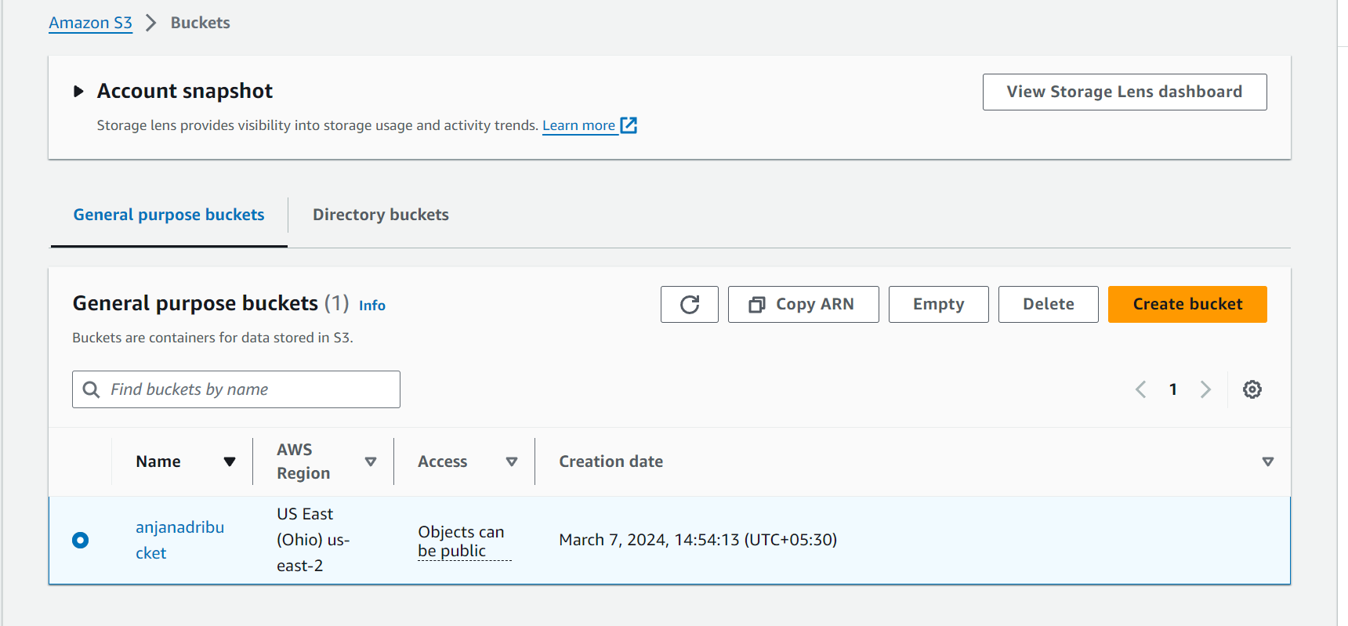

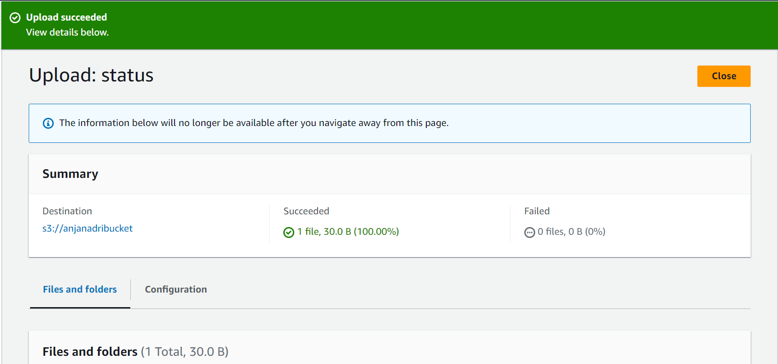

Lab 2

Task 1

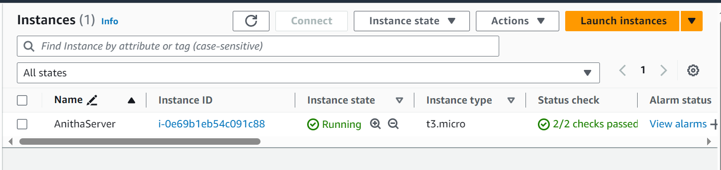

Task 2

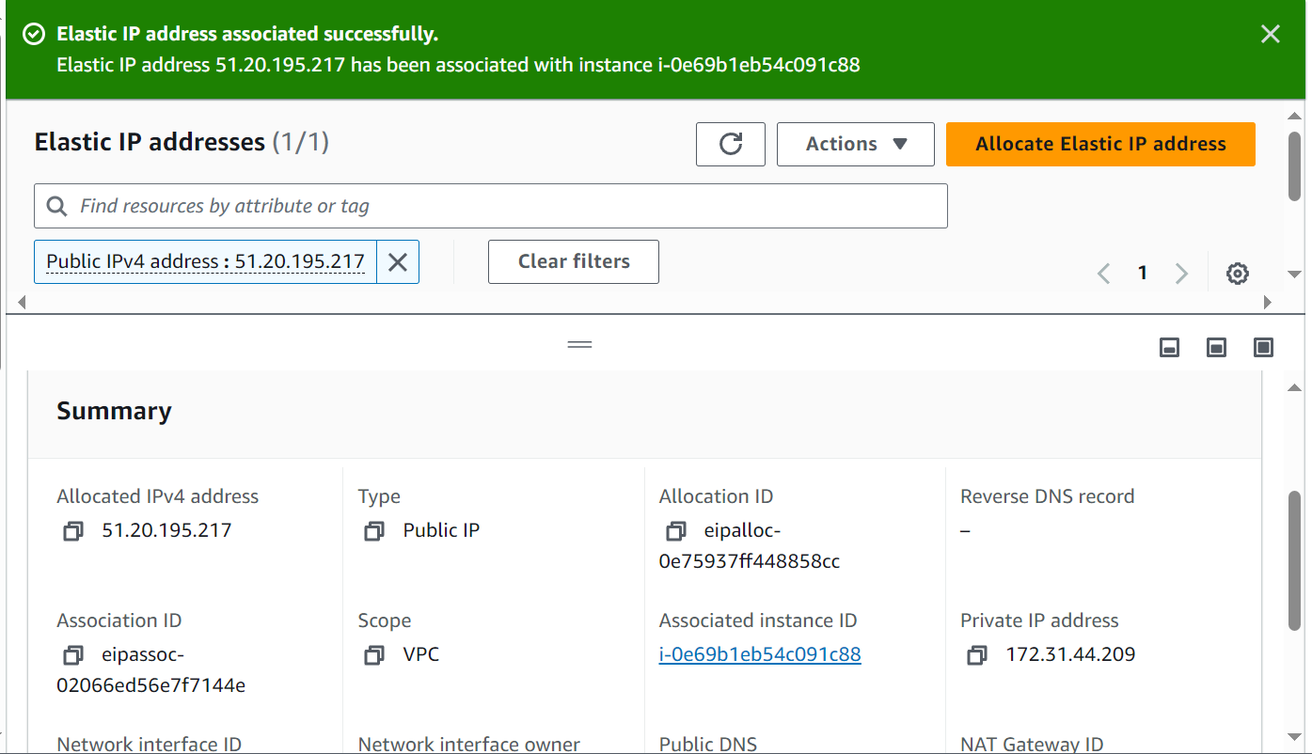

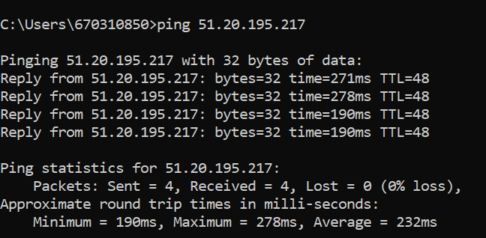

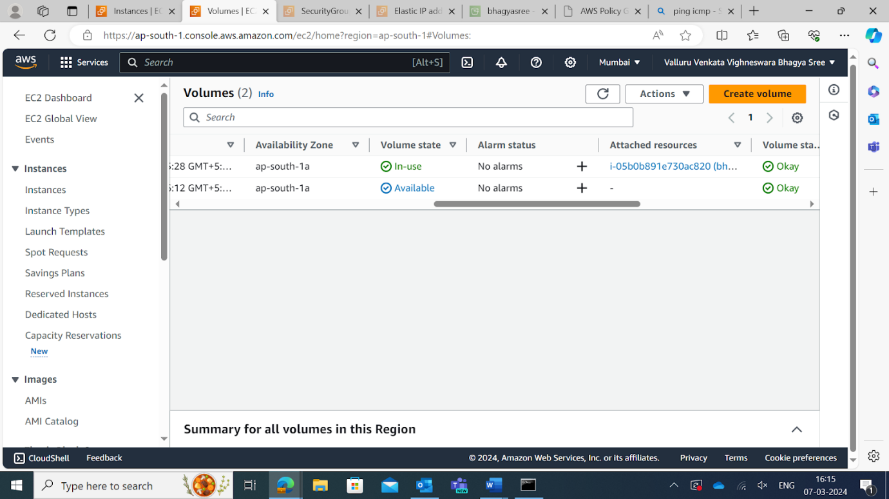

Lab 4

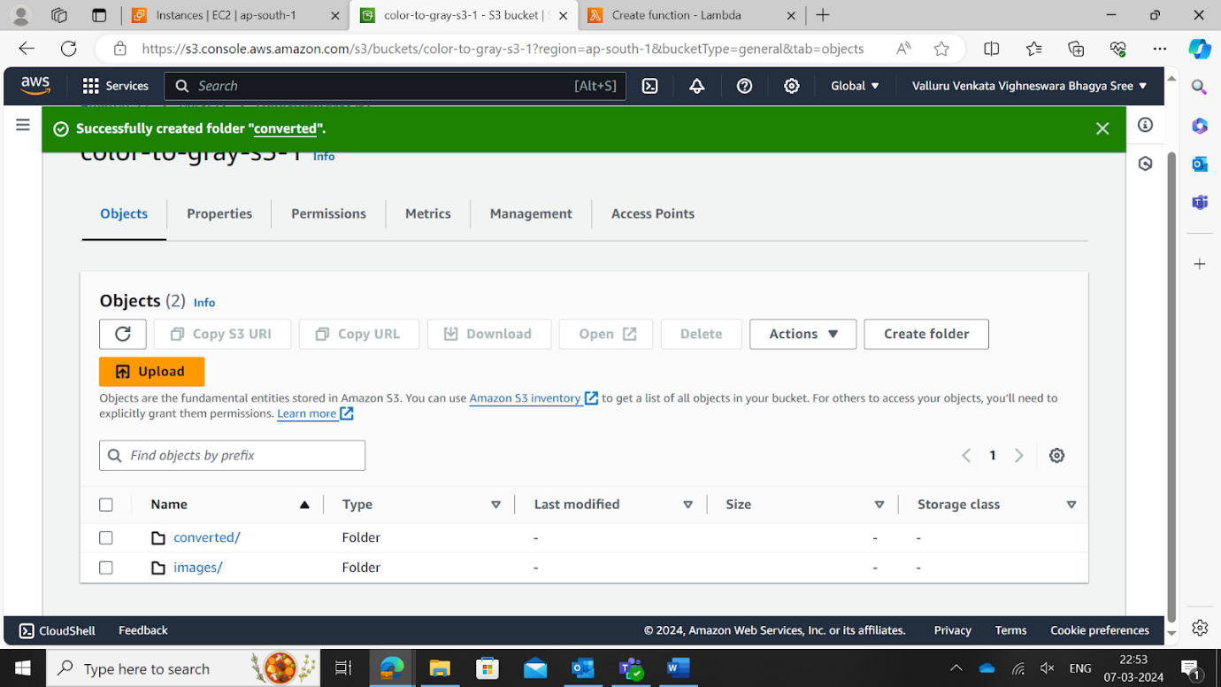

Lab 5



